2012 SMALL GRAIN PERFORMANCE TRIALS

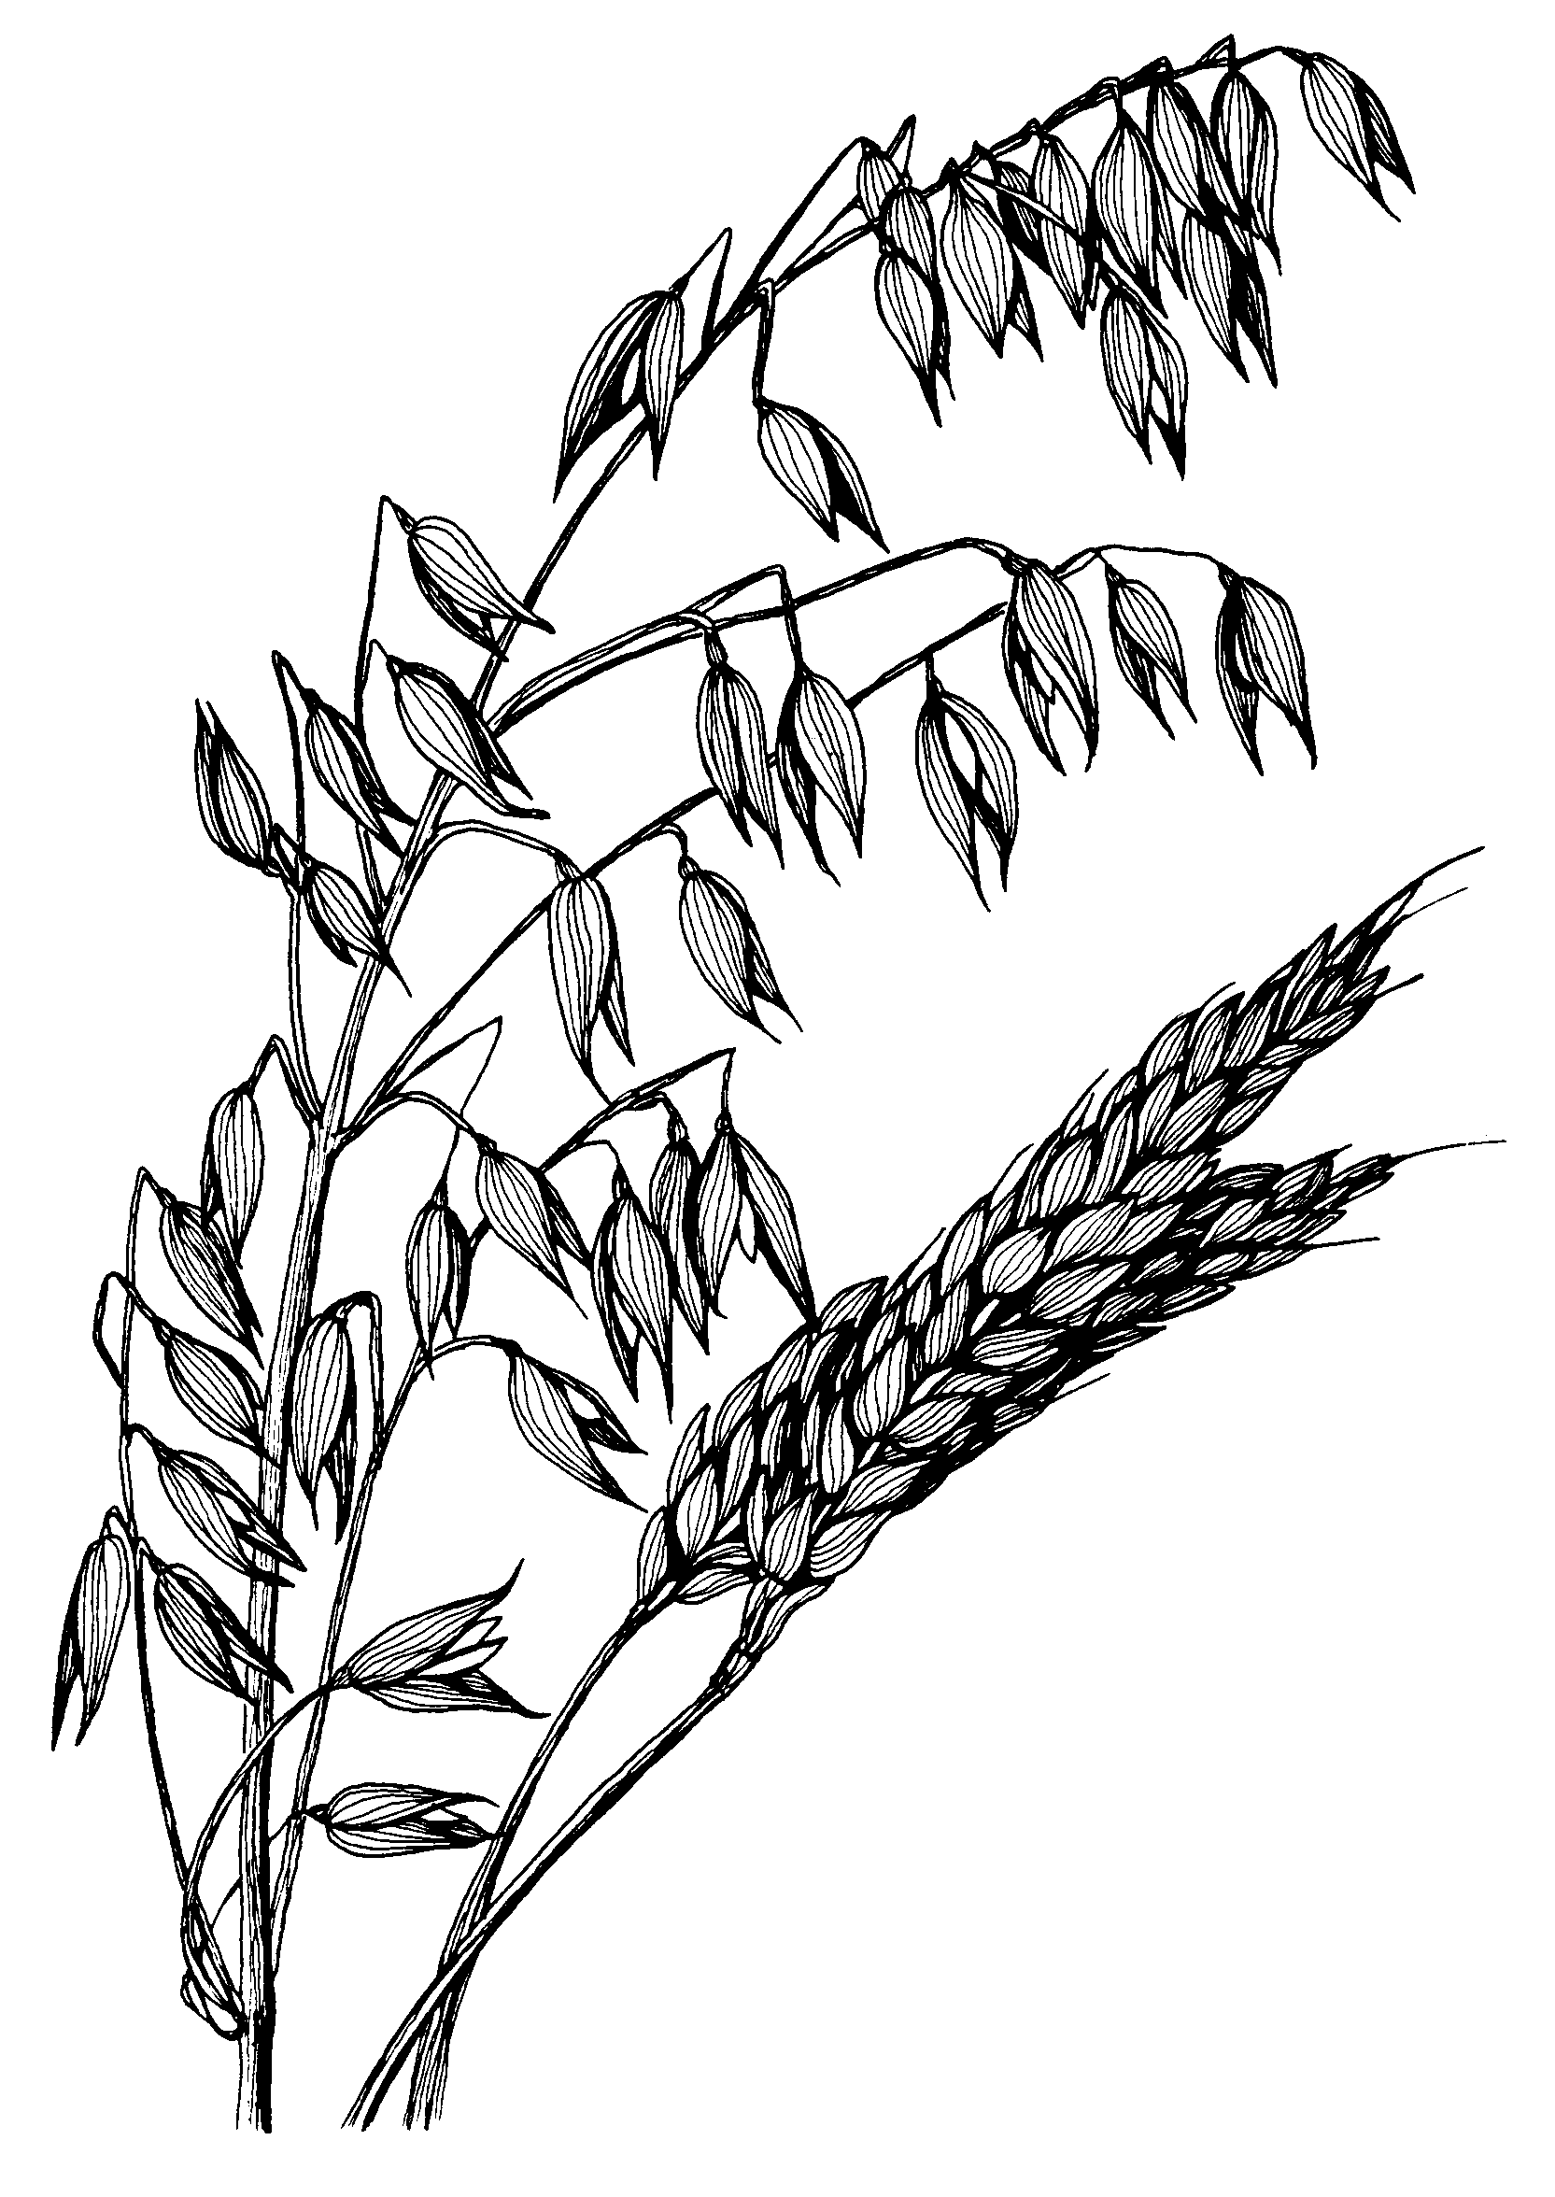



LAES Research Summary No. 194

August 2012

