Nutrition News
Southwest Region Monthly Nutrition Newsletter January 2021

Chew on This: January is Family Fit Lifestyle Month
Now that a new year is upon us, nearly everyone has a goal of becoming healthier with diet and exercise. Becoming fit as a family is a great way to spend time together, teach essential life skills, and show your kids the importance of leading a healthy lifestyle as they grow up. Children need 60 minutes of exercise per day and adults need about 30 minutes per day most days of the week. The adult recommendation equals 150 minutes per week for good health. When the weather is nice, take advantage and move those fitness activities outdoors like walking, bike riding, playing Frisbee, or ball. In January, the weather can be cold or rainy; however, do not let it stop you from being active. Families can do various indoor activities to stay fit, including dance parties, Simon says, an indoor obstacle course, or an exercise video on TV or the internet.
One way that the family can get fit together indoors or outdoors is to make a fitness ball. For under 5 dollars, you can make this and use it to promote physical activity as a family. You will need either an old ball or a beach ball (at least 12”) that has been inflated, a permanent marker, and a list of fitness activities (below or make your own). Using the marker write 2-4 fitness activities on each panel of the ball. Once you have completed writing the fitness activities, you are ready to use it. Some ideas are:
• Hot potato. Have music playing while everyone tosses the ball in a circle. Once the music stops, the person holding the ball will pick the fitness activity closest to their right thumb. Once the activity is completed, put the music is back on and resume playing.
• Toss the ball amongst others, and when it is caught, the activity closest to the left thumb is done by everyone.
• Have everyone sit in a circle and roll the ball to each other with music playing. Have someone stop the music and the person who has the ball pick the fitness activity everyone does closest to their right thumb.
• Be creative and make up your own game with the fitness ball.

Health Awareness
January is
Spaghetti Day 4th
Bean Day 6th
Granola Day 21st
Peanut butter Day 24th Blueberry Pancake Day 28th
Family Fit Lifestyle Month
Oatmeal Month
Slow Cooking Month
Wheat Bread Month

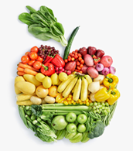

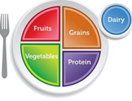

Keep in mind that in addition to regular exercise, a healthy diet is important too. Try to offer your family various fruits, vegetables, low-fat or fat-free dairy products, lean sources of protein, and whole grains to your family for optimal nutrition. If possible, try to eat as a family two or more times a week and make meal preparation something the entire family can be involved in.
You can use any of these activities to make your fitness ball:
5 squats
10 toe touches
10 forward arm circles
Run in place for 10 counts
3 planks for 20 seconds each
10 lunges
5 side to side jumps
5 windmills
10 backward arm circles
5 sit-ups
10 shoulder rolls (5 forward and 5 backwards)
5 jumping jacks
5 jumps to the sky
10 hops on one foot (5 on left and 5 on right)
10 arm lifts
8 squats
5 push ups
5 hop in place

Information adapted from the Academy of Nutrition & Dietetics Association and the University of Nebraska at Lancaster Extension Service.
Get Moving: Go Play, Your Way!
Incorporating 30 minutes to an hour of physical activity into you and your family’s life is an important part of a healthy lifestyle. An easy way to get fit as a family is setting a time to turn off screens and be active together. Start small and use what you have available. Some examples of this include walking, jumping rope, playing tag, and even dancing! You can also take physical activity breaks during screen time. Even things that you do around the house, including yard work and mopping, is a form of physical activity. Use experiences as a form of being active by treating your family to a trip to the zoo or park. Remember, kids, need at least one hour a day or physical activity while adults need a minimum of 2-1/2 hours a week. By being a role model to your family, you are likely to set the tone for healthy habits in your household.
Source: Choosemyplate.gov
Healthy Communities Showcase
To learn more about Healthy Communities in your parish, please contact your local extension office.


What to plant now | Days until harvest
Spinach | 35-45
Kale | 40-60
Mustard greens | 35-50
Lettuce | 45-80
Get Growing: Gardening
Hopefully, most of your garden is in the ground and you are harvesting some great produce. If not, you can still plant beets, broccoli, cabbage, carrots, cauliflower, and eggplant. Nature has intended the harvest time of citrus to be during flu season. Your garden is packed with vitamin C and antioxidants to prevent you from getting sick. January is a great time to harvest citrus fruits as a family. Feel free to pick all the citrus off of your trees and juice them. You can certainly freeze the juice for a later recipe. You can make snacks for your kids by dehydrating citrus slices or you can use them for garnish. You can add the slices or juice to poultry or pork for added flavor when baking. If you do not have a garden, have no worries. Visit your local farmer’s market to benefit from the local and healthful produce this season has to offer. Farmer’s markets are a great place to take family walks and enjoy the fresh air. Visit https://www.ams.usda.gov/local-food-directories/farmersmarkets to locate the farmer’s market that is closest to you.

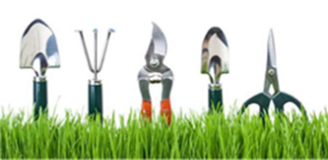


HTTP://BIT.LY/SNAPEDSURVEY

Stirring it Up: Chicken Noodle Soup
Chicken, vegetables, and egg noodles combine for a hearty soup!
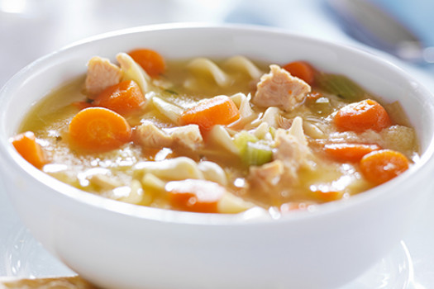
Ingredients
- 3 pounds bone-in chicken pieces (skin removed)
- ½ teaspoon salt
- ¼ teaspoon black pepper
- 1 onion (chopped)
- 1 cup celery (washed and chopped)
- 3 carrots (large, scrubbed, thinly sliced)
- 4 cups noodles, dry
- thyme or sage (optional)
Directions
1. Thaw frozen chicken in the refrigerator (about 24 hours), or thaw in the microwave just before cooking soup.
2. Place chicken pieces in a large kettle. Cover completely with water. Cover, bring to boil, reduce heat, and simmer 2-3 hours.
3. With soap and water, carefully wash your hands and any counter surfaces and equipment that came in contact with raw chicken.
4. Remove cooked chicken pieces from broth with tongs or slotted spoon. Cool 10-15 minutes before separating bones from meat. Break the meat into bite-size pieces. Remove any bones from broth.
5. Remove fat from the broth by skimming with a spoon, adding and removing ice cubes, or blotting the top of the broth with paper towels.
6. Put chicken meat, seasonings, and vegetables into stock.
7. Bring broth to a boil, cover, reduce heat, and cook about 15-20 minutes on medium heat until sliced carrots are crispy tender.
8. Add noodles and boil uncovered for about 6-7 minutes, stirring occasionally to break up any noodles that might stick together. (One cup of dry noodles (1.5 ounces) makes one cup of cooked noodles).
9. Ladle into soup bowls. Sprinkle with thyme or sage to season.
10. Refrigerate or freeze leftovers within 2 hours of cooking. If refrigerated, use within two days. When reheating, bring to a boil.
Note: Makes 6 servings
Nutrition Information
Nutrition Information for 1 serving Calories 276; Total fat: 5g; Saturated fat: 1g; Cholesterol: 109mg; Sodium: 228mg; Total carbohydrate: 24g; Dietary fiber: 2g; Protein: 32g; Total Sugars: 3 g; Added Sugars included 0 g
Source: University of Minnesota, Cooperative Extension Service, Simply Good Eating Recipe Cards, Vol. 1, 2000 link to recipe
https://www.myplate.gov/recipes/supplemental-nutrition-assistance-program-snap/chicken-noodle-soup
SW Region Nutrition Agents: Mandy Armentor, MS, RD, LDN, FCS Regional Coordinator; Shatonia McCarty, MS, RD, LDN; Becky Gautreaux, MA, RD, LDN; Tiffany Williams, MS, RD, LDN; Amanda Gibson, RDN; Jessica Randazzo; Maria Gonzales; Tamika Jones

