Nutrition News
Southwest Region Monthly Nutrition Newsletter December 2020


Chew on This: Have a Healthful Holiday Season!
The holidays are here and are filled with fun family gatherings, traditions, and food! Unfortunately, this tends to be when it is the hardest to stick to your health goals. Being healthy does not have to be hard by making a few alterations to your holidays. Use this time to make your family’s favorite recipe a little bit healthier! Choose low-sodium canned vegetables in recipes, substitute applesauce for oil in your baked goods, and use reduced-fat cheeses in your meals. Pack your dinner table with produce by choosing sides that have fresh vegetables. Don’t forget to include different colors of vegetables and fruits on your table to get the most nutrients. If you’re not in charge of dinner, no problem! Eat a small snack before attending your holiday feast so you won’t be so tempted to overeat. Staying healthy also means avoiding food-borne illnesses. Wash hands often, check the temperature of your cooked meals with a food thermometer, and avoid cross-contamination. Choose the holidays to make healthy habits together as a family.
Get Moving: Go Play, Your Way!
Getting some physical activity does not have to be hard, and despite what you may have heard, it does not have to cost an arm and a leg! Most adults should get at least 150 minutes of physical activity a week. Remember, doing something is better than nothing! Physical activity can mean a walk in the park or be up and moving with your kids. A good idea for people with dogs or children is to get into a routine of taking 10-minute walks before starting your day, maybe at lunch and/or an afternoon walk. This is already 20 minutes of physical activity a day! Stopping at the grocery store on your way home? If you feel safe, it is a great idea to park further away from the store to get your daily steps in! If you have access to a computer, smartphone, or smart TV, you can watch free workout and exercise videos to help you reach your physical activity goal by the end of the week. Working out doesn’t have to be expensive and should comfortably fit into your daily schedule.
Health Awareness
December is
Eat a Red Apple Day 1st
Pie Day 1st
Microwave Oven Day 6th
Ice Cream Day 13th
Oatmeal Muffin Day 19th
Handwashing Awareness Week 7th-13th
Pear Month
Safe Toys and Gifts Month

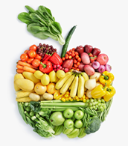

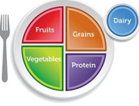

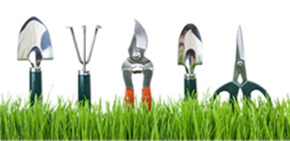

Get Growing: Gardening
Gardening provides health benefits beyond fresh food, such as improved mental health, increased exposure to Vitamin D, and moderate physical activity. Louisiana’s mild weather allows for year-round vegetable planting. Leafy vegetables, such as lettuce, swiss chard, broccoli, cauliflower, cabbage, Brussels sprouts, and carrots thrive in the colder, shadier months. These varieties can be planted as late as mid-October. For successful winter gardening, plan ahead by determining the location and spacing of your garden. At least 6 hours of sunlight is preferred. Correct spacing between and within rows is critical for proper growth, cultivation, and efficient space use. In the home garden, you can space plants 4-6 feet apart. Alternatively, all winter crops can be grown in 2-gallon containers with manufactured soil. Most seeds should be planted two to three times their depth and width. Plants need 1-2 gallons of water per week. The water should reach deeper than just the surface soil. It’s best to water early in the day, so the foliage dries off by evening. When plants are watered at night, the foliage stays wet for an extended period, and disease problems build up. For more information on gardening and specific planting instructions, please visit LSU AgCenter's Website .

What to plant now | Days until harvest
Onions | 120-150
Shallots | 50
Spinach | 35-45
English peas | 60-70
Turnips | 40-50
Healthy Communities Showcase
To learn more about Healthy Communities in your parish, please contact your local extension office.

Holiday Food Safety Tips
- Wash your hands for 20 seconds before, during, and after cooking.
- Use a food thermometer to ensure that food is cooked thoroughly.
- Be aware of the food temperature danger zone of 40-140°F. Bacteria multiply rapidly at these temperatures. Food can only be left out for up to two hours after cooking. After two hours, it should be discarded.
- Avoid cross-contamination.
- Separate raw foods from cooked foods.
- Cook foods to the correct internal temperature.
- Clean all surfaces.

Stirring it Up: Roast Turkey Breast with Rosemary, Sage, and Thyme

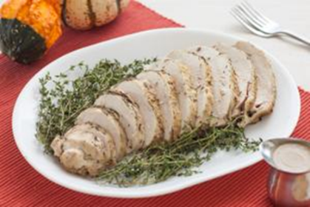

Ingredients
- 3 pounds turkey breast half (with skin and bones)
- 1 large onion, quartered
- 1 large carrot, quartered
- 1 teaspoon dried sage
- 1 teaspoon dried thyme
- 1 teaspoon rosemary
- 3 tablespoons olive oil
- salt and pepper (to taste, optional)
- chicken broth (or margarine, for basting, optional)

Directions
1. Preheat oven to 400°F. Place turkey breast in roasting pan along with onion and carrot.
2. Mix spices with olive oil. Rub turkey with olive oil.
3. Roast turkey at 400°F for 15 minutes. Baste with margarine or chicken broth (optional).
4. Reduce oven temperature to 350°F and roast turkey, basting every 20 minutes with pan juices (or margarine or chicken broth), about 1 hour and 15 minutes, or until a meat thermometer inserted in the thickest part of meat registers 165°F.
5. Remove to a carving board and let rest for 10 minutes. Makes 8 servings.
Nutrition Information for 1/8 of recipe
Calories 213; Total fat: 6g; Saturated fat: 1g; Cholesterol: 96mg; Sodium: 67mg; Total carbohydrate: 3g; Dietary fiber: 1g; Protein: 35g; Total Sugars:1 g; Added Sugars included 0 g

Source: link to recipe https://www.choosemyplate.gov/recipes/supplemental-nutrition-assistance-program-snap/roast-turkey-breast-rosemary-sage-and-thyme

Perfect for a holiday gathering, this roast turkey breast can be prepared in less time than a whole turkey. Enjoy!
SW Region Nutrition Agents: Mandy Armentor, MS, RD, LDN, FCS Regional Coordinator; Shatonia McCarty, MS, RD, LDN; Becky Gautreaux, MA, RD, LDN; Tiffany Williams, MS, RD, LDN; Amanda Gibson, RDN; Jessica Randazzo; Maria Gonzales; Tamika Jones

