2010 SMALL GRAIN PERFORMANCE TRIALS

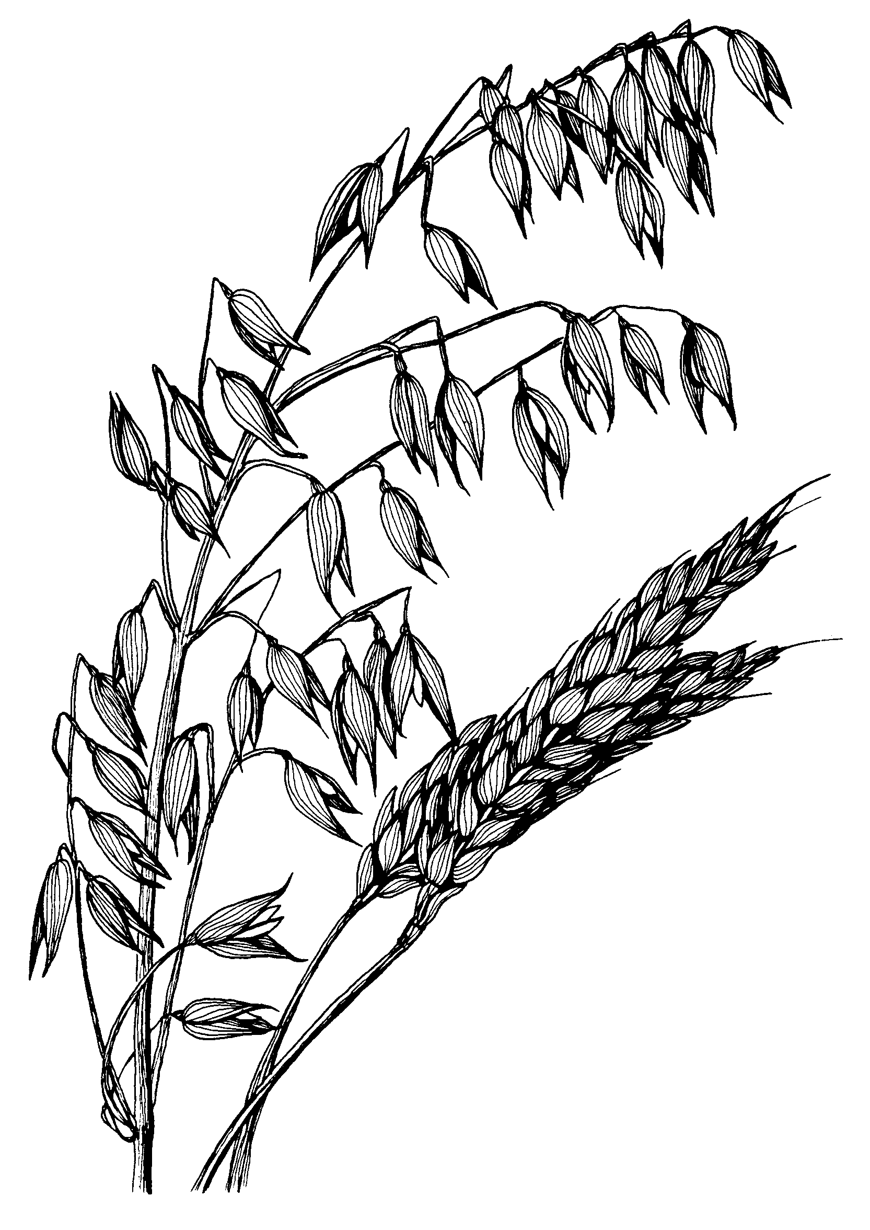

LAES Research Summary No. 185

August 2010


